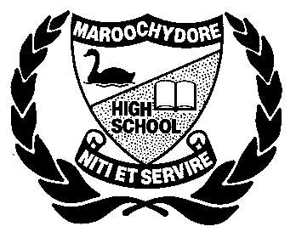**Monohybrid Genetic Crosses**

You need to know the following terms and be able to use them to answer questions. Genetics is like learning another language and you must be familiar with the terms so that when you read a question you understand what it is saying.

* **Dominant genes** are ones that mask other characteristics. We show them with a capital letter.
* **Recessive genes** are masked by dominant ones. We show them by a lower case letter.
* **Homozygous recessive** = 2 lower case letter and displays recessive trait (bb)
* **Homozygous dominant** = 2 Capital letters and displays dominant trait (BB)
* **Heterozygous** = 2 different letters and displays dominant trait (Bb)

‘Homo’ means same and ‘hetero’ means different.

**Complete the following sentences in your notebooks:**

(Words: dominant, homozygous, punnet, genetics, recessive, lower, heterozygous, recessive)

1. The study of inheritance is called ______.
2. A ______ gene is one that is masked by other characteristics.
3. Recessive genes are masked by ________ ones. They are shown using a ______ case letter.
4. Represented with 2 lower case letters is ____________ ________________.
5. Represented with 2 different letters ___________.
6. The box used to show a genetic cross is called a ________ square.

**Multiple Choice - Circle the correct answer on the sheet.**

**1.** The scientific study of heredity is called

a. meiosis

b. crossing-over

c. genetics

d. pollination

**2.** Which of the following is a genotype for a homozygous dominant gene pair:

a. AA

b. Bb

c. cc

d. dD

**3.** A segment of DNA that controls a particular hereditary trait is called a(n)

a. genotype

b. allele

c. trait

d. gene

**4.** Having two similar, dominant alleles for a trait is called

a. homozygous dominant

b. monohybrid cross

c. heterozygous

d. phenotype

e. genotype

**5.** An organism having two different alleles for a trait is called

a. heterozygote

b. homozygous dominant

c. monohybrid cross

d. phenotype

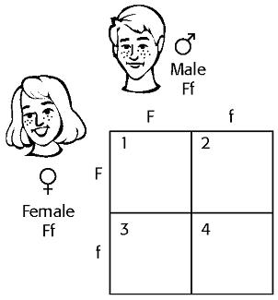

**6**. In humans, having freckles (F) is dominant over not having freckles (f). Using the Punnett square below to complete the cross shown.

**7.** Refer to the illustration above. The genotype represented in box 1 in the Punnett square would   
a. be homozygous for freckles.   
b. have an extra freckles chromosome.   
c. be heterozygous for freckles.   
d. have freckles chromosomes.

**8.** Refer to the illustration above. The genotype in box 3 of the Punnett square is

a. FF.

b. ff.

c. Ff.

d. None of the above

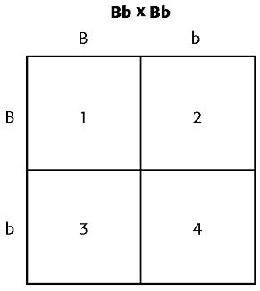9. In rabbits, black fur (B) is dominant over brown fur (b). Complete cross on the right between two rabbits.

10. Refer to the diagram on the right. The box shown, used to complete a genetic crosses, is called   
a. Mendelian box.                              c. genetic graph.   
b. Punnett square.                              d. phenotypic paradox.

11. Refer to the diagram on the right. Both of the parents in the cross are   
a. black.

b. brown.

c. homozygous dominant.

d. homozygous recessive.

12. Refer to the illustration above. The phenotype of the offspring indicated by box 3 would be   
a. brown.

b. black.

c. a mixture of brown and black.

d. The phenotype cannot be determined.

j0239353**Answer the following questions in your notebook**.

13. Tallness (T) is dominant to shortness (t) in pea plants. Complete the following crosses in your notebook drawing a Punnett Square for each cross. Write the phenotype and genotype next to each cross.

a) Homozygous dominant x homozygous recessive

b) heterozygous x homozygous recessive

c) heterozygous x homozygous dominant

14. If short hair in rabbits is dominant (H) to long hair (h) determine the expected outcome if two heterozygous rabbits bred. What genotype and phenotypes are expected amongst their offspring?

15. In cattle dogs the gene for having short fur is dominant (T) over the gene for having long fur (t). If I cross a homozygous short fur male with a homozygous long fur female what are the possible phenotypes and genotypes of the offspring?

16. Clear wings in bats is dominant (G) over grey wings(g). What will be the offspring if:

1. a heterozygous clear male is mated with a grey winged female.
2. a homozygous recessive male is mated with a heterozygous clear female.

j033051317. In dogs, wire hair (S) is dominant to smooth (s). In a cross of a homozygous wire-haired dog with a smooth-haired dog, what will be the phenotype and genotype of the offspring (F1 generation)?

18. What would be the expected offspring if two dogs from the F1 generation were crossed?

19. Use a Punnett square to solve a cross between two parents that both have the genotype Yy.

j023358920. Using these alleles, R = red flower and r = yellow flowers, write all possible genotypes & phenotypes.

 21. Using the information from the above question (Q.20) complete the following crosses and state the genotype and phenotype of each:

1. homozygous red flower x yellow flower
2. heterozygous red flower x yellow flower
3. homozygous red flower x heterozygous red flower
4. yellow x yellow flower

22. In humans, having freckles (F) is dominant over not having freckles (f). Using a Punnett square below complete the crosses below showing the phenotype and genotype for each.

a) Heterozygous male x female with out freckles

b) Homozygous male with freckles x female with no freckles

c) Homozygous male with no freckles x Homozygous female with freckles